Capital Asset Reporting for Non-EIS Districts

For those districts that DO NOT USE EIS, you will be required to use EMISFFE to enter your capital asset information. The steps to complete this are provided below:

https://ssdt.esu.k12.oh.us/emisffe2/login/auth
- Log into EMISFFE
  - You can also find this web page by going to www.noacsc.org , and under ‘Fiscal Services’, ‘Fiscal Links’, click on ‘EMISFFE (Flat File Editor)’.
  - If your password has expired, you can reset it on this web page by clicking on ‘Forgot password?’.
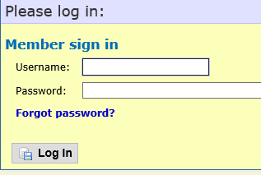

- After logging in, it displays the main menu along with your district’s IRN only (not the district name). Click on the “Capital Assets (QC)” link to add your capital asset data.

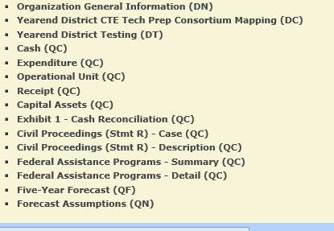

MODIFYING AN EXISTING RECORD
- An “Edit” option is available to modify a record that already exists. You must first select a record from the “Capital Assets List” by clicking on the “ID #” in order to edit it.
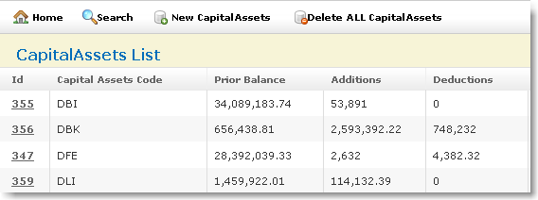

Click on EDIT to edit the existing record.

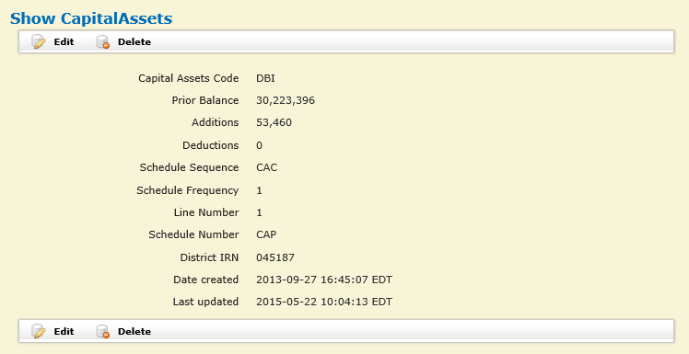

Modifiable fields include the Capital Assets Code, Prior Balance, Additions and Deductions. Click on “Update” to complete the changes.

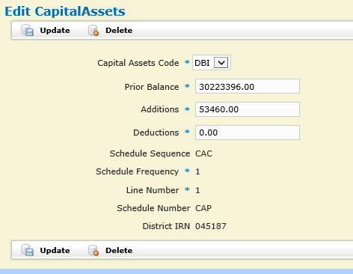

NOTE: You also have the option to DELETE a record.

When you are finished creating/updating your capital asset records, you may click on “CAPITAL ASSETS LIST” to review a listing of your capital asset data. NOTE: In most cases, there are no validations done within the FFE application. If bad data is inputted into a field, the record may be saved without errors. You won’t find out about the bad data until you receive the validation reports from EMIS-R.

ADDING CAPITAL ASSET DATA
- From the home screen click on Capital Assets (QC) (step 2 of this document to take you to the Capital Assets List, if you aren’t currently there.) Click on “NEW CAPITAL ASSETS” to add a record for FY2016.
  - On the “Capital Assets Code” box, select a code from the drop down list. A listing of available codes and their meanings are on the last page of this document
  - Enter the prior year balance. You will need to reference either last year’s (FY2015) ending balance or this year’s (FY2016) beginning balance for the amount for this code
  - Enter total amount of additions (items added) during FY2016 for this asset code
  - Enter total amount of deductions (items deleted) during FY2016 for this asset code.
  - Click on “CREATE” when finished and repeat step 3 if you need to enter additional capital asset codes.

DBI Depreciable Capital Assets, Buildings and Building Improvements
DBK Depreciable Capital Assets, Books
DFE Depreciable Capital Assets, Furniture, Fixtures and Equipment
DIN Depreciable Capital Assets, Infrastructure
DLI Depreciable Capital Assets, Land Improvements
DVE Depreciable Capital Assets, Vehicles
LBI Accumulated Depreciation, Buildings and Building Improvements
LBK Accumulated Depreciation, Books
LFE Accumulated Depreciation, Furniture, Fixtures and Equipment
LIN Accumulated Depreciation, Infrastructure
LLI Accumulated Depreciation, Land Improvement
LVE Accumulated Depreciation, Vehicles
NDC Capital Assets not being depreciated, Construction in Progress
NDL Capital Assets not being depreciated, Land

NOTE: Please refer to the last page of this document if you would like further explanation on the above asset categories.

EXPORTING FILE
- From the main EMISFFE menu (Click Home), select “Export Data” to extract data into a flat file format
  - Select the fiscal year 2016 and reporting period “H – July Financial”. When the reporting period is selected, the record types that are valid for “H” are automatically check marked for exporting. Make sure only the “QC Financial Data” record and “DN Organizational General Information” boxes are checked. Then click on Export File to begin extraction process. 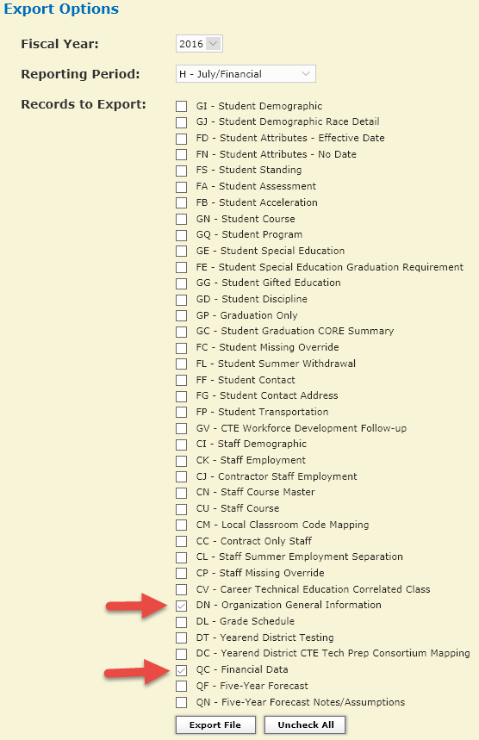

- Choose Save/Save As to save the file to your desktop using either the default file name or a name of your choosing. The filename extension must be .SEQ.

- Load Flat File Editor export file into Data Collector
  - Login to the Data Collector
    - https://emisapp.noacsc.org/DCConsoleJSP/dc/Login.jsp
    - You can also find this web page by going to www.noacsc.org , and under ‘Fiscal Services’, ‘Fiscal Links’, click on ‘Data Collector’.
    - Your Data Collector username begins with ‘DC.’ followed by your district code. For example DC.XX.treas
    - If you forgot your Data Collector password, go to https://dcpassword.noacsc.org/change/ and click on ‘Reset DataCollector Password’. NOTE: Your Email Address for this process is xx_treas@noacsc.org, where xx is the two letter code for your district. Ex: pg_treas@noacsc.org
  - Data Sources
  - Other Data Sources
  - Manage
  - Click on ‘Upload File(s)’
  - Browse for the file you created in steps 5 and 6 above
  - Click on ‘Upload’
  - Confirm that the file has the appropriate date, time and that the file size is greater than zero.
    - If the file has an old date, or the size is zero, contact NOACSC.

CAPITAL ASSET CATEGORIES
The following definitions determine the asset category in which an amount should be included for capital asset reporting (found in Section 6.6 4 of the Current EMIS Manual).
- Land - A fixed asset account which reflects the acquisition value of the land owned by the school district. This account includes the purchase price and costs such as legal fees, filing and excavation costs, and other associated improvement costs incurred to put the land in condition for its intended use. If land is acquired by gift, the account reflects its appraised value at the time of acquisition.
- Land Improvements - A fixed asset account which reflects the acquisition value of permanent improvements, other than buildings, which add value to land. Examples of such improvements are fences, retaining walls, sidewalks, pavements, gutters, tunnels and bridges. If the improvements are purchased or constructed, this account contains the purchase or contract price. If improvements are obtained by gift, it reflects the appraised value at the time of acquisition.
- Buildings and Building Improvements - A fixed asset account which reflects the acquisition value of permanent structures, used to house persons and property owned by the school district. If buildings are purchased or constructed, this account includes the purchase or contract price of all permanent buildings and the fixtures attached to and forming a permanent part of such buildings. This account includes all building improvements. If buildings are acquired by gift, the account reflects their appraised value at the time of acquisition.
- Furniture, Fixtures, and Equipment - Tangible property of a more or less permanent nature, other than land, buildings, or improvements thereto, which is useful in carrying on operations. Examples are machinery, tools, furniture and furnishings.
- Vehicles – Examples are trucks, cars, and buses.
- Infrastructure – Example is sewage treatment plant
- Books – Examples are textbooks and library books.
- Construction in Progress - The cost of construction work undertaken but not yet completed

