STRS Rate Change

STRS has been increasing the employee rate by 1% each year. This is the final year.

Effective July 1, 2016, the employee rate will increase from 13% to 14%

How USPS handles the rate change

When the STRSAD program is run at Fiscal Year End for ‘actual’ (option 2), the system stores the percentage rates that exist in DEDSCN at that time. So the old rate is saved in a temporary file and any accrued wages paid on advanced jobs will continue to use that rate. If you have deductions by job implemented on your retirement records, the job number assigned for any advanced jobs will be stored in the temporary file that is created.

Below is a screenshot of what you will see when you run the Actual of STRSAD. Notice it indicates that it is saving current percentages. The tape submission file name is also displayed; this file is only created when the Actual is run.

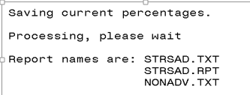

What about new earnings?
If the advance job also has new earnings on it, such as a miscellaneous (MIS) payment, or the employee has a separate job that is not in advance, the system uses the withholding rate on the DEDSCN (new rate) for calculation of the retirement.

In this situation when RETIRE/STRSREG is processed, 2 totals will be provided for the employee. One total for the ‘advanced’ contributions withheld at the old rate and one total for the new contributions withheld at the new rate.

When the advanced job is completely paid and the new contract purged, the new contract will withhold at the new rate.

In the STRSREG report example below the employee’s primary job is in Advance at the FY16 rate of 13%. They were also paid for 4 extra days they worked in July so the FY17 rate of 14% applies. The Advance amount line is marked with a ‘!’ symbol and you can see that 13% of the earnings was calculated for the contribution amount. The other line is for the extra days worked in July and you can see that 14% of the earnings were calculated for the contribution amount.

RETIRE/STRSREG Report

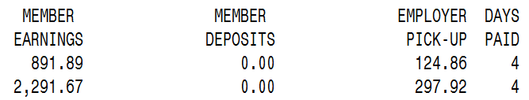
4 days @ 14%
Accrued wages @ 13%

When an employee’s job is in Advance, the FYTD Gross Pay on the 450 DEDSCN record and the FYTD Deduct Total on the 591 and/or 691 DEDSCN record are not updated with accrued wage amounts. Only new earnings will update these fields. These amounts are used for reporting on the next fiscal year (2016-2017) STRS Annual Report.

The screenshot below for the 450 DEDSCN record FYTD Gross pay for the employee only shows the 891.89 paid for the extra 4 days worked in FY17.

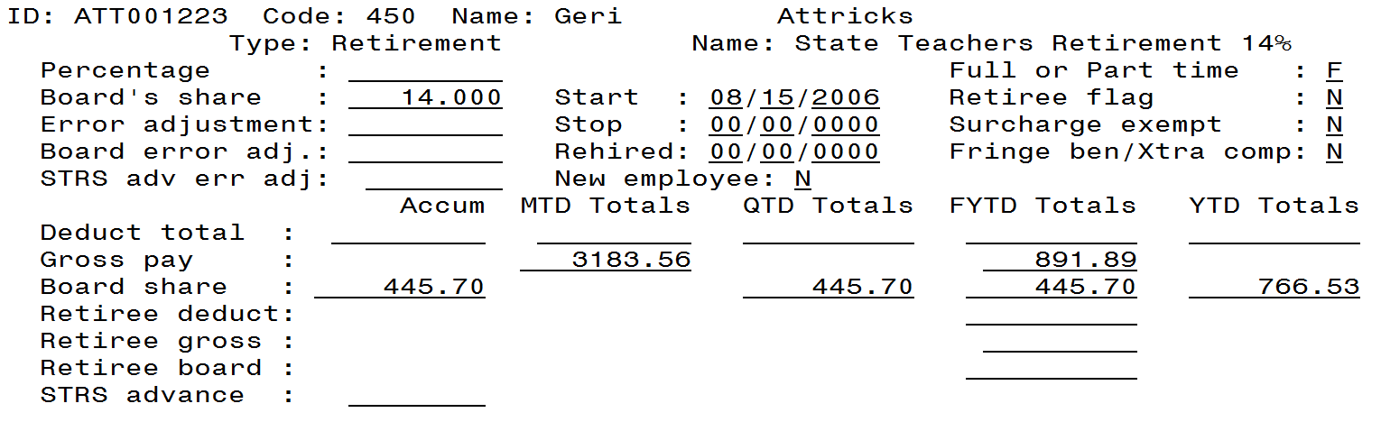

The screenshot below for the 591 DEDSCN record FYTD Deduct total for the employee only shows the 124.86 contribution for the 891.89 paid for the days in July at the 14% rate. Notice there is an STRS advance amount line which shows the contribution amount for the advance amount paid at 13%.
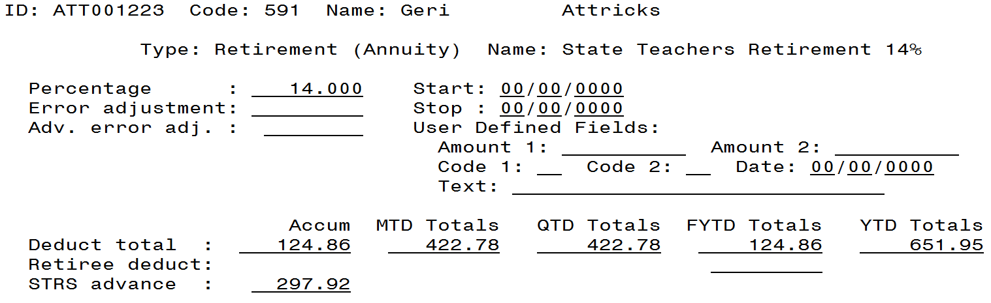

When and how to change the rate

Before the first July payroll and after running STRSAD, Option “2”, you will want to run the CHGDED program, option C, and mass update the rates to 14% on the 591 records (see example below). Keep in mind; CHGDED will only update the records whose DEDSCN rates match the old rate entered in CHGDED. Because of this, you may have to run CHGDED several times.

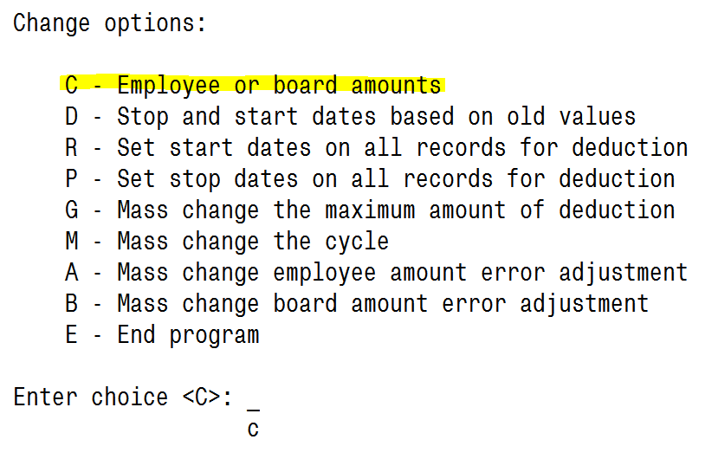
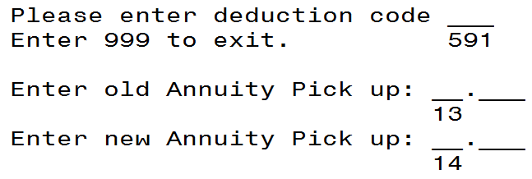

You can also manually update the rates directly in DEDSCN as well or the new rate can be loaded from a spreadsheet. Please contact us if you need any assistance.

Pickup on Pickup Rates

If you have employees with full pickup on pickup with extra compensation paid by the board, the rates will increase as follows if the Board is going to continue picking up the extra percentage:

Effective July 1, 2016, the 450 deduction will increase from 15.82% to 15.96% and the 691 deduction will increase from 14.69% to 15.96%

If you have partial pickup on pickup with extra compensation paid by the board then you will need to calculate your rate. The following link will take you to the SSDT USPS User Guide chapter explaining retirement calculations. Please contact us if you need assistance.
https://wiki.ssdt-ohio.org/display/usps/Calculating+Regular+and+Pick-up+Retirement

(New) Important: If your school provides pickup on pickup with extra compensation paid by the board and the board’s rate is NOT going to change for FY17 (which means the employee will pay the extra percentage for the year), please be aware that the board percentage will still increase slightly.

For Example, if the board picked up the full 13% last year for the pickup on pickup contribution, but the extra 1% for FY17 will NOT be picked up by the Board, there will still be a slight increase in the 691 DEDSCN percentage. Since the pickup is to be included in compensation for retirement purposes, the annual increase to 14% will cause the rate to be a little higher, instead of 13.56% it will be 14.82%.

Here is an example of why this is occurring.

If an employee has an annual salary amount of $40,000 and Board pays pickup on pickup with compensation 13% and the employee pays the other 1%, the calculation is made as follows.
$40,000 x 13% Board Pickup = $5,200
Compensation paid by the board is then based on $45,200 and the full STRS rate for the year.
$45,200 x 14% full rate for FY17 = $6,328 - So this is the total amount the owed to STRS.
$40,000 x 14.82% (increased rate for FY17) = $5,928 Board Pays
$40,000 x 1% = $400 Employee Pays
Total paid to STRS is $6,328 ($5,928 from Board and $400 from Employee)

STRS needs to be notified as to whether or not you will be picking up the additional percentage. Also, you will want to look at the original Board resolution to see if it indicates the Board will be picking up a specific percentage. Board resolution may need to be amended. If a new resolution is passed be sure to submit it to STRS with a cover sheet

Timesheet Employees
So what do you do with employees that submit a timesheet for work in June but aren’t paid until July? If at all possible, it would be best to pay them on the last pay of June at the old rate. If this is not possible then you just need to be consistent with how you have reported earnings in the past. If you paid amounts in July for June earnings and have always reported those amounts as earnings and contributions in July, then you should do so again. Even though the rate changes, you should be consistent with how you have reported in past years. Most districts report June earnings in July for the new fiscal year. You might want to think of this situation as related to how the IRS handles tax rate changes from year to year. They don’t expect you to adjust the tax rate for money earned in December that was paid in January.

However, if in the past you paid amounts in July for June earnings and have always reported those amounts as earnings and contributions for the prior fiscal year by notifying STRS to back post to the previous year, you should do so again. There are not many districts that use this method but there a few that do. If you are not consistent in how these have been reported in the past, the contributions for the employees will be inflated one year and reduced the next and may affect the retirement benefits due to these employees.

If you need to report a payment made in July for June (or prior) earnings and report them for the prior year with the old rate, the following steps should be followed:

*Please note: These steps are only used when the employee is ONLY being paid prior year earnings in the new fiscal year to be back posted with STRS. If the employee also has earnings in the new year, see the options available to process starting on page 6 of this document.

When payment is made, withhold retirement at the old rate by making sure the DEDSCN rate is set to the old rate. After CHKUPD is run, modify the rate to the new rate and also modify the affected DEDSCN records to back out the amounts on the FYTD total fields. Backing out the amounts from these fields will prevent them from being reported on the next STRS Annual Report.

In this example, the employee was paid $200 in July and the district withheld at the prior year rate and will report it to STRS for the prior year. On the 450 DEDSCN record, the FYTD gross of 200.00 will need to be removed. It is not necessary to update the Board Share FYTD total because it is NOT used for the Annual Report, but you can if you wish. If the employee is a rehired retiree, update the retiree gross field as well.

On the 591 DEDSCN record, the FYTD deduct total of 26.00 will need to be removed. If the employee is a rehired retiree update the retiree deduct field as well.

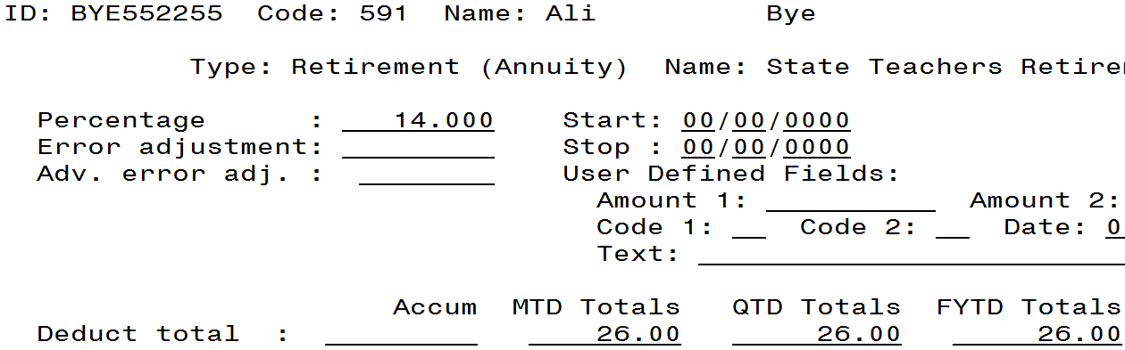

STRS should be notified to back post the payment to the previous fiscal year. This can be done by contacting STRS or by entering the back posting in the STRS ESS (Employer Self Service) website.

Keep in mind that contributions made at the 13% rate should be reported for the 2015-2016 fiscal year and contributions made at the 14% rate should be reported in the 2016-2017 fiscal year. This applies to the annual report, STRSREG will always list the earnings and contributions per pay regardless of which year they were applied.

REMINDER: MAKE SURE THE RATE IS CORRECT IN DEDSCN FOR THE NEW FISCAL YEAR!

What about timesheet employees that have earnings in both June and July that will be paid in July?

STRS has stated that they do understand that there are situations where it is difficult to process payments at different rates and therefore, they suggest processing the most convenient way for the district. So in this scenario it is okay to process those earnings in July at the 14% rate and report them on that fiscal year’s annual report. Again, it comes to consistency…if you haven’t made an adjustment in previous years to report the June earnings in the previous fiscal year then continue to report as you have.

However, if you have back posted the June earnings in the past or if for some reason you do want to pay the June earnings at 13% to report in the previous fiscal year, then you can process it through payroll one of two ways.

Deductions by Job Method

If earnings for June apply to one job and earnings for July apply to a different job you can use the Deductions by Job method to apply the correct rate to the appropriate job. For example, the employee below is a teacher in advance and they also have a summer school job (02) and tutoring job (03) paid by timesheet. The employee worked 5 days in June for summer school and 2 days in July for Tutoring. They will be paid on the July 31 payroll. In order to withhold the summer school job at 13% and the tutoring job at 14% deductions by job can be setup.

To implement deductions by job, go to USPSDAT/DEDNAM and mark the ‘job level’ flag to ‘Y’ on the 450 and 591 records.

Then you can create another DEDSCN record for the employee specifically for the job to be withheld at 13% as shown in the example below. A corresponding 450 DEDSCN for the specific job number will also need to be established in order to create the 591 record.

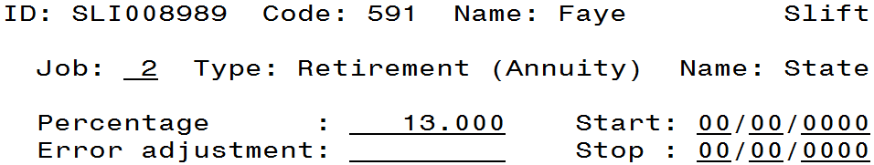

The original 450 and 591 DEDSCN record can be left as is and all other jobs will use the rate listed on those records. Because the employee’s job 01 is currently in advance it will use the rate saved when STRSAD Actual was run. But when the job is no longer in advance it will use the rate in the DEDSCN records with no job level marked.

When the payroll for the payments has been completed don’t forget to remove the FYTD Gross on the 450 and the FYTD Deduct Total on the 591 record (for job 2 in this example as shown below). This will prevent them from being reported on the annual report. You will need to contact STRS to back post these amounts to the previous fiscal year or you can post it on the STRS ESS (Employer Self Service) website. This applies to the annual report. STRSREG will always list the earnings and contributions per pay regardless of what year they apply to.

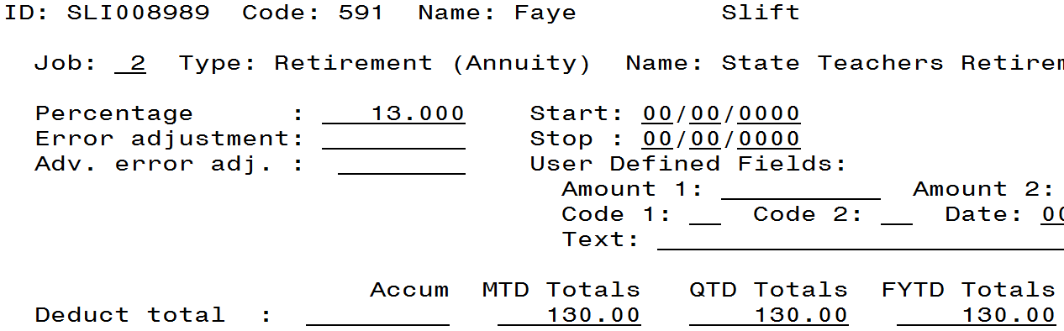

If the employee is a retired retiree, update the retiree gross (450) and deduct (591) field as well.

Error Adjustment Method

If amounts for June and July are being paid on the same job and you are going to withhold at the different rates, you can calculate how much is to be withheld at each rate. Once calculated, use the 591 DEDSCN record to withhold at the current 14% rate and then enter a negative error adjustment amount to bring it back down to the calculated amount.

For Example: If a regular teacher whose job is in advance has also worked summer school from June 22 (7 days) to July 3 (3 days), and you are going to withhold the 7 days from June at 13% and the 3 days from July at 14%, you would start by calculating what should be withheld. Using a daily rate for these days of $50, the calculation would be as follows:

7 days x $50 = $350 x 13% = $45.50
3 days x $50 = $150 x 14% = $21.00
Total withholding is $66.50

The 591 DEDSCN record is setup at 14% withholding, therefore the system will calculate withholding on the full $500 for $70. The difference between the system withholding and the calculated withholding amount is $3.50. So on the 591 DEDSCN record you can enter a negative error adjustment of -3.50 as shown below. Be careful not to enter the adjustment in the ‘Adv. Error adj.’ field.

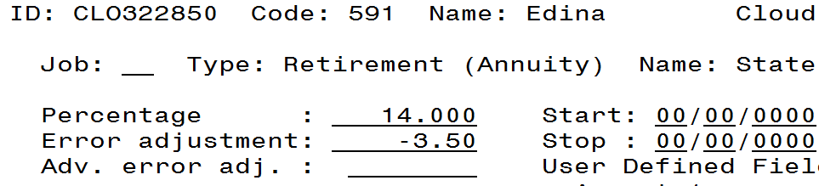

*NOTE: After processing the payroll, you will need to adjust the FYTD amounts on the 450 and 591 DEDSCN records to remove the amounts that will be applied to the
2015-2016 fiscal year, as shown in the following screenshots. This will affect the STRSAD annual report only. The full earnings and contribution amount will be reported on STRSREG. So, in the example above, $500 earnings and $66.50 withholding will be listed for this employee on STRSREG. You will need to either contact STRS to backpost these amounts to the 2015-2016 fiscal year or you can post it on the STRS ESS (Employer Self Service) website.

In this example on the 450 DEDSCN record, reduce the FYTD Gross Pay amount from 500.00 to 150.00. If the employee is a rehired retiree update the retiree gross field as well.
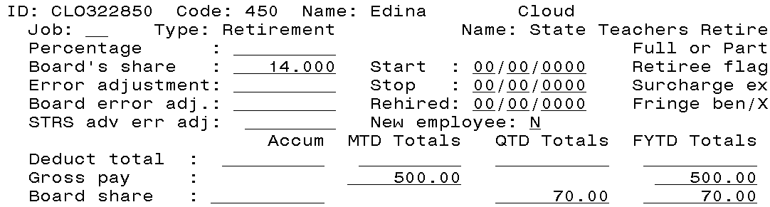

On the 591 DEDSCN record, you can see that the correct withholding amount which was manually calculated was withheld. Now we need to reduce the FYTD Deduct Total amount from 66.50 to 21.00. If the employee is a rehired retiree update the retiree deduct field as well.
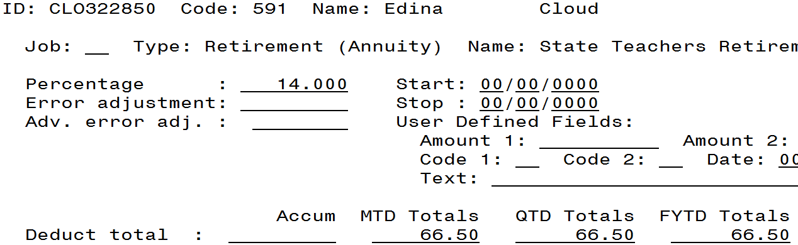

REMINDER: If you back post earnings to the previous fiscal year you may need to make an adjustment for service credit. If the employee will receive 120 days in the current fiscal year then this won’t be an issue.

What about Administrators whose contract goes until the end of July?
Start withholding at new rate (14% as of July 1, 2016).

Retirement Withholding Based on Earnings
We don’t believe we have any districts that use this method but if you do, the following applies to only your district.

If a district uses an inflated rate on the STRS deductions to withhold the retirement for all pays in a lesser number of pays, the district action is dependent on how the deductions are inactivated. If the district has the ITC change the STRS withholding flag to ‘by earnings’, the district must change the rates prior to any July pays. The record update is necessary so any new earnings have retirement calculated at the new rate. If the district processes this by stopping the retirement deductions, the district will want to update the rates at the time new earnings must be paid on the jobs.

Suggestions
- Please pay off anything you are aware of for FY16 with your last pay in June.
- If after July 1, it is necessary to pay something for the prior fiscal year in which many employees need to be paid
  - Example:
    - A grade card stipend for the prior fiscal year
  - The following is suggested:
    - Mass change the DEDSCN to 13% by using CHGDED.
    - Run a special pay for the prior fiscal year earnings.
    - Adjust the accumulators as in previous examples.
    - Create a back posting for STRS.
    - Mass change the DEDSCN to 14% by using CHGDED.
    - Run a regular pay.
- Negative accruals – Days are paid in June for days earned in July. As discussed at the STRS workshop, technically days earned in June should be paid at 13% and days earned in July should be paid at 14%. However, if the system cannot do this for these few individuals, a “split” pay (one week earned in June/one week earned in July) at the rate in effect on the pay date when the contributions are paid as agreed by STRS Ohio and state software is recommended. If this is done, the contributions need to be included on the correct year’s Annual Report and be consistent each year as the rate changes.

