2017 USAS Calendar Year-End Procedure

The following checklist outlines the steps needed when closing out USAS for the month, quarter and calendar year-end.

Deadline to Submit 1099’s to NOACSC is January 17th, 2018!

*USAS Close must be done after last payroll and deductions of December are posted to USAS through Autopost, but is independent to payroll closing.

District 1099 Procedures

- Run TINMATCH if desired. USAS_ANN/TINMATCH (Tax ID Number required starting in 2015 closeout).

- Use USASCN/VENSCN to enter the TIN number and enter (S) for SSN or (E) EIN on all 1099 Vendors before your final run of F1099.

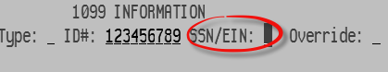

- Run VENSSN for 1099 processing. Verify all vendors flagged to receive 1099’s are accurate and have a social security or tax ID number.

          - Option 4 will give you a listing of all 1099-MISC Vendors AND YTD Activity that meet IRS reporting requirement
          - Option 5 will give you a listing of all vendors that are NOT 1099-MISC Vendors AND YTD Activity > $599.99
          - Option 6 will give you a listing of all 1099-MISC vendors regardless of the YTD Activity amount.

Check the vendor names. If the vendor uses a different name for 1099 reporting than what is normally used for checks, enter the “1099:” and the reportable name on the “2nd Name” field in VENSCN. For example:
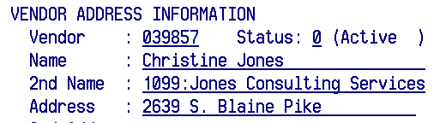
The F1099 program will strip off the “1099:” and use Jones Consulting Services for 1099 reporting.
- Run the F1099 program.
NOACSC will print the District’s 1099 forms through EDGE and mail to the district.

The F1099 program looks for any vendor flagged for 1099 reporting with a YTD total equal to or greater than the minimum amount entered by the user.

There is an “override” flag on VENSCN that will generate a 1099, regardless of the YTD amount. This flag is shown below:

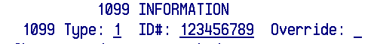

If you choose to use this flag, the vendor will receive a 1099 regardless of whether or not they meet the minimum reporting amount, as long as their YTD total is > $0.

**The override flag can also be found in USASWEB – Vendors

When running the F1099 program, you may choose to suppress 1099’s for any vendors without a 1099 Id number.

Answer “N” to the “Create Tape Submission File” prompt until you have confirmed the data and are ready for the final fun.

Following are the prompts for the F1099 program.
When you run F1099 to create the tape file, the Payment Year entered needs to be 2017.

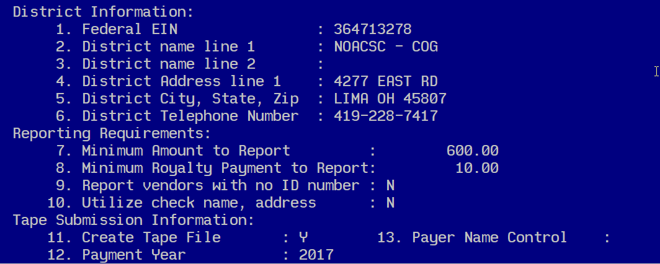

The following files are generated:

- F1099.TXT – report of 1099 vendors sorted by income type
- F1099.DAT – a data file which can be used for laser printing. Please do not print this file
- F1099.FRM – file containing vendor 1099 information to be printed on blank 1099 forms
Please do not print this file
- F1099.TAP – tape file containing the vendor 1099 information to be sent to the IRS.
Please do not print this file

- Once data is confirmed, run F1099 and answer “Y” to create the tape file.
- Once the information on the 1099 report is verified and correct and the tape file has been created, enter the command at the menu prompt: 1099_PRINT
This program submits your 1099’s for printing. NOACSC will print the District’s 1099 forms through EDGE and mail to the district. After giving this command,

WAIT for a mail message!

The mail message should state the following:
“Your 1099 forms have been queued for printing at the NOACSC. You may proceed.”

If you receive an error, please contact NOACSC.

- If you want NOACSC to submit the file to SSA, please send an email to usas_liaisons@noacsc.org. We will submit your 1099 information to the SSA office using electronic media, if you wish. However, if you have 250 or more 1099’s, we must submit for you!

1099 Frequently Asked Questions

Q. I’m not ready to run the F1099 program yet. Can I still close for the calendar year?

A. F1099 must be run from files which contain the correct Calendar YTD totals, thus it must be run prior to running calendar year-end ADJUST.

Q. I forgot to report a 1099 vendor.

A. If NOACSC has not sent the tape to the IRS yet, we could access the backup files to correctly code the vendor and re-run the F1099 program for you, in order to get the vendor onto the tape file. You will receive a new F1099 report and the 1099 forms can either be reprinted, or you can hand-type the additional 1099 form.

Q. I made a reporting mistake on one of my 1099 vendors. Is it too late to correct it?

A. This is basically the same situation as above. If however the tape file has already been submitted, you will need to see the 1099 General instructions for details on exactly how to fill out and file a correction form.

Q. How do I change the amount reported for a 1099 vendor?

A. Same answer as above.

Q. Do I need to report 1099’s to the state?

A. No, Ohio does not require 1099 reporting.

Q. I can’t get the tax ID number for a 1099 vendor!

A. Reporting a 1099 without a tax identification number may cause the district to get penalties. The F1099 program will allow you to bypass these vendors if they choose to do so. Correct procedures for handling this situation, including initiating backup withholding, are described in the 1099 General instructions.

Q. Deceased employees, medical waivers, etc. – how are they reported?

A. Check the 1099 instructions for any specific details on who/how to report. Any questions along these lines not answered by the instructions should be referred to IRS.

Please remember Wednesday, January 17, 2018 deadline for 1099’s!

Regular Monthly Closeout Procedures

- Enter all transactions for the current month.

Reconcile USAS records with your bank(s). (The following are recommended procedures as outlined by the SSDT. You may use your own monthly reconciling procedures or use the ones below.)
- Perform the Bank Reconciliation Procedure described in the "Useful Procedures" section of the USAS User Manual.

- Generate Cash Reconciliation using the cash reconciliation (option 1) of the USAS_ANN USAEMSEDT program, FINSUMM, PODETL (Outstanding PO’s) and BALCHK Reports.

- Examine the MTD, YTD, and FYTD Expenditure lines on the BALCHK report. The dollar amounts for cash, budget, and appropriation accounts should be identical for each line on the report.

- Examine the MTD, YTD, and FYTD Revenue lines on the BALCHK report. The dollar amounts for cash and revenue accounts should be identical for each line on the report.

- Compare Current Encumbered totals from the BALCHK and PODETL reports. They should be identical. If they are not, execute the program FIXENC to correct and then regenerate BALCHK and compare totals. If the totals still do not balance contact NOACSC for assistance.

- Run FINSUMM, selecting “Y” to “Generate FINDET report for comparison” option. This will cause the FINDET report to be generated with identical selection criteria as the FINSUMM and will determine if it balances with FINSUMM. The total will display on the screen. Compare the total from FINDET and FINSUMM. They should be identical.

- If all the above steps are performed and totals all agree, you are in balance and may proceed.

- If desired, run the CALC option from the SM12 program. Print the resulting report.

- Generate all needed Month-End Reports. The following is a listing of the MINIMUM report listings recommended for retention on a monthly basis:

- USARPT/BUDSUM using YTD (or Split) Budget Summary-All Funds
- USARPT/APPSUM using YTD (or Split) Appropriation Summary-All Funds
- USARPT/REVSUM using YTD option Revenue Summary-All Funds
- PODETL- Detail of all Funds in Account Order
- USARPT/FINDET and USARPT/FINSUMM Reports
- RECLED Reports-All Funds, All Options
- CHEKPY Detailed Check Register and Outstanding Checks for the Month
- USAEMSEDT Cash Reconciliation Report

- Run BWC (if you haven’t already run this in USPS processing)

BWC will run the BWCRPT program twice, once for sort option FUND, SCC, FUNC, and OBJ, and again for sort option FUNC, OBJ. This procedure will send an email message to you and USAS_LIAISONS when complete. We will copy these reports to the web. You may find these helpful when filling out your Worker’s Compensation report.

Your screen will show the following:
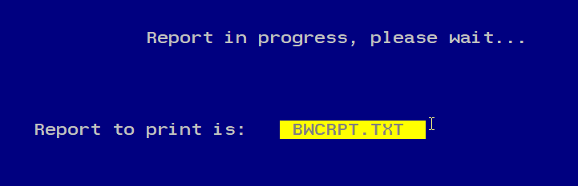

Please do not print bwcrpt.txt. The program renames the file.

The output text files are:
BWCRPT_FO.txt
BWCRPT_FSFO.txt

- Contact NOACSC 419-228-7417 to close any hung sessions.

- Run the program MDADJUST. The MDADJUST program will automatically run the MonthlyCD program and then when that is finished run the adjust program for the month. When the procedures gets to the adjust program you need to select the “Month End” option.

- Run VENHIRE/VHRESET

VHRESET will reset all vendors flagged as “reported” back to “reportable” indicating the vendor may need to be reported again if they are paid at least $2,500 during the next calendar year.

REMINDER – Districts should be running the program VENHIRE/VHREPORT option every other week or twice a month to catch any new hires that have reached the $2,500 threshold for reporting.

- If little time has passed since you last called us and you are confident that everyone is out of your files, there is no need to call us. If not please contact us at 419-228-7417 to check for any hung sessions.

- Run the ADJUST program selecting the “Year End” option and run for

“CALENDAR”

- No other programs (USAS or USPS) can be used when running ADJUST.

- Run the USERLIST report program for your district.

Notify Jennifer Schwartz (Jschwartz@noacsc.org) of any usernames that should be deleted.

- CONGRATULATIONS! Begin January 2018 processing.

