USPS Fiscal Year End Procedures

Pre-closing

STRSAD must be processed by all payroll users and the advance as listed must be accurate. The STRS report will be sent electronically. Everyone must report electronically.

ALL ADVANCES MUST BE PROCESSED THROUGH THE PAYROLL OR THE PAYROLL SYSTEM WILL NOT WORK CORRECTLY

The employee termination date on BIOSCN must be updated when an employee leaves the district. This field should not be confused with the termination date on job records. STRSAD will check the employee termination date, not the job termination date. Employees flagged as part-time will be given credit according to STRS rules outlined in the STRS Employer’s Manual.

- Date / Time

If you have anyone retiring at the end of the school year, process the NC1 payment now for the cost of life insurance if insurance is valued over $50,000. Use the pay type NC1 in UPDCAL/FUT or UPDCAL/CUR for the taxable amount of the life insurance. See document ‘Reporting Taxable Amount of Life Insurance Premiums’.

- Date / Time

Create job calendars for FY16-17.

This can be done with the Using the program USPSDAT/CALMNT. You should _NOT_ delete the old calendars, but just continue to add months on your current calendars. CALMNT also offers a COPY feature to help when you have multiple calendars.

- Date / Time

New Contracts can be entered if using the NEWCNT program.

- Date / Time

Complete FY16 Staff EMIS Checklist for Final Staff and Course Collection.

- Date / Time

To determine if an employee's job is to be advanced, verify the following information for each job using the report called ACCRUED_WA (MENU> ACCRUED_WA):

      - The days worked in contract must be equal to work days in Contract.
      - The Number of Pays Paid in Contract must be less than the Number of Pays in Contract.

- Date / Time

To verify the status of the part-time/full-time fields on the 450 deduction records, run the report STRS_STATU (MENU>STRS_STATU) and review the STRS_STATUS.TXT report.

- Date / Time

If aware of dock amounts that will be paid on the 1st July payroll, or any payrolls after that, enter the amounts in ‘DOCK NEXT PAY’ field on JOBSCN.

This will cause the STRSAD report to calculate the correct amounts.

- Date / Time

If you are aware of any early contract pay offs, change the number of pays.

- Date / Time

Run STRSAD. This program will process the advanced STRS annual report. You should first run STRSAD with option 1. This will give you the opportunity to review reports for errors. The report names are:

- STRSAD.TXT - This report will just list the employees that will be advanced and the amounts. If you run this before the last payroll in June, (just to check it out), you might not get everyone on the report, because they might not have worked all of their contract days. Employees reported in the advance mode should be consistent with prior years. Check supplemental contracts. For employees to be reported on this report they will need to have:

- Work days equal to days worked
- Amount remaining to pay greater than zero
- Pays greater than pays paid

You will see an accrued contribution amount calculated for each advanced employee. This accrued amount will be the amount of earnings not yet paid times the employee’s STRS withholding rate.

Accrued contribution amount is calculated using the pay per period from JOBSCN for the remaining pays minus 1, then the last pay calculation occurs.

STRSAD Accrued Contribution sample calculation:

Obligation = 39100
Pay per period = 1504
paid = 26/22
23rd pay 1504 x 13% = 195.52
24th pay 1504 x 13% = 195.52
25th pay 1504 x 13% = 195.52
26th pay
Obligation 39100
- Paid 25 pays 37600
Remaining 1500 x 13%=195.00
Total accrued contributions calculated by STRS
195.52 + 195.52 + 195.52+195.00=781.56

- STRSAD.RPT - This report will list all employee deposits and advanced amounts and give you a grand total of all deposits.

Refer to the handout on STRSAD report explanation which includes a copy of the STRS Decision Tree.

Employee’s service credit needs to be verified here.

- Employees with 120 or more days receive 100% credit
- Employees with less than 120 days receive credit based on STRS decision tree.
- Employees classified as part-time have service credit based on STRS decision tree
  - Part-time flag on 450 must be set as needed
  - If uncertain of an employee’s status contact STRS
- Re-Employed retirees will always have 0% credit reported with contributions.
  - Calculated service credit for rehired retiree will flag a warning on the STRSAD.RPT report.
- Staff retiring and rehiring in the same fiscal year will appear twice on the report, one line for contributions earned prior to retirement and one line for contributions earned after retirement.
- Balance the amount showing in the Deposits/Pickup column included on the report. This amount should be the total of deduction checks already written to STRS plus the warrant checks for pickup amounts.

- NONADV.TXT – This report will list employees that are not to be advanced. You should check this report to make sure a job or employee isn’t missed.

Verify the data on all three reports and check for errors. Reference the handout STRSAD Errors and Warnings for a listing of common errors.
IF YOU HAVE ERRORS, DO NOT PROCEED!!! CONTACT NOACSC.

- Date / Time

Finish final payroll for the fiscal year.
Only run QRTRPT for the demand option ‘N’!!!!!

USPS Fiscal Year End Procedures

- Date / Time

Rerun STRSAD for option 1 (see step 9)

- Date / Time

If you made any corrections, return to step 11. If STRSAD.RPT is correct, there are NO errors, ALL warnings are checked out and known to be correct, and the employee statuses for STRS are correct, then run STRSAD for option 2. This will ACTUALLY UPDATE YOUR FILES. This procedure also creates a file (STRSAD.1606) which is the file to be sent to STRS. Please note; the start date is based on the Academic Calendar, the first day the students are in session.

Each district will submit this file to STRS using the program ANNSTRSSND.

Be sure to print and save the three report files, STRSAD.TXT, STRSAD.RPT and NONADV.TXT, generated by this program. These reports are also created and saved on the Payroll Web Page reports.

- Date / Time

Run the program ANNSTRSSND

**If you are a RENHILL/WIXEY district, do not run ANNSTRSSND until after the file is received from Renhill/Wixey and merged with your data

This program works in the same manner as the transmission of the STRS per pay data submissions (STRS_SEND). It will send your annual report on to STRS. This option should only be processed once.

A message will be displayed on the screen when the file is successfully sent to STRS.

RESTRICTIONS:
Once a district is in "advance mode", the job is flagged as an advanced job if the work days in the contact equals contract days worked and there are still pays remaining on that job.

You may make additional payments on advanced jobs, and the software will be able to determine what should be considered as payback on the advance and what should be considered new earnings. This means that there will be no need for you to add new jobs for your STRS advanced employees just for the purpose of making additional payments on a job. The software will automatically determine which payments are new earnings, which is all pay types with the exclusion of “REG” (regular), “ACC” (accrued), and “BCK” (retro). This means that you can make a “MIS” (Miscellaneous) payment on an advanced job and the miscellaneous payment will be considered new wages while the regular wages will be considered payback to the board.

If you would like to know how the STRSAD program calculates the amount of the advance and how the pay back during the summer months should work, please refer to https://wiki.ssdt-ohio.org/display/usps/strs+advance for more information. This chapter explains a little bit about the STRS Advance, which fields affect the STRS advance, the Calculations, the STRSAD program, balancing and checking your reports and the payout and payback.

- Date / Time

Run ODJFSRPT for 2nd quarter 2016. You should print ODJFSRPT.TXT.

If you find errors on the number of weeks worked for any employees, you can make corrections in USPSCN/ATDSCN. Then re-run ODJFSRPT and verify your report. THERE ARE 13 WEEKS IN THIS QUARTER.

- Date / Time

Send a mail message to USAS_LIAISONS@NOACSC.ORG when your STRS advance and ODJFSRPT reports are completed.

- Date / Time

Make sure ALL --JUNE-- late distributions have been distributed. (Don't do July's) Check with your treasurer. This is a file that should have been processed through AUTOPOST.

- Date / Time

Run the SURCHG program if desired. This program is designed to assist you with verifying the SERS surcharge calculations and GAAP reporting.

- Date / Time

Notify michelle@noacsc.org that your SURCHG report is complete. You can EREPORT it to yourself and then forward it to Michelle. She will add this to your fiscal year end payroll reports on the web.

- Date / Time

Run all the quarterly reports you normally do at the end of the quarter, BUT DO NOT RUN QRTRPT!

- Date / Time

Run the programs BENOBL and WAGOBL. There are two options in these programs. It is recommended that you run both of these report programs for both report options. One option will give you the balances broken down by employee, the other option will give you the balances broken down by account. In recent audits most auditors have asked for these reports. Also, you need the account reports for GAAP reporting. Run them at this time and file them.

- Date / Time

Run USPRPT/CHKSTS for ALL PAID checks. Make sure ALL RETURNED checks HAVE BEEN RECONCILED.

- Date / Time

Run QRTRPT selecting the demand option (N). Check all totals for accuracy.

Deduction totals should equal the total of all deduction checks written for the period(s) being checked.

Gross amounts should equal the total of all payroll clearance checks issued during the particular period(s) being checked.

Balance the ‘Adjusted Gross’ on QRTRPT. If the calculated adjusted gross equals the total adjusted gross the difference will be listed as 0.00. Differences should be resolved.

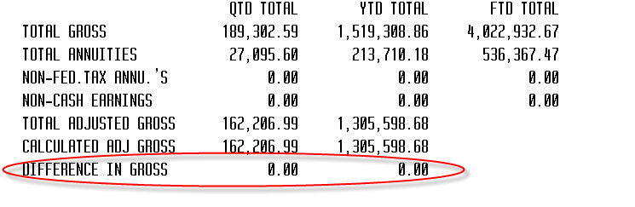

1. Run QRTRPT for option N.
2. Print QRTRPT.TXT (check all totals, once correct, proceed)

***DO NOT run QRTRPT for fiscal year end! That will be done for you automatically in step 11.***

It is recommended that you balance the W2REPT quarterly to minimize problems at calendar year end. Run the W2PROC program and check the W2ERR.TXT report for errors. Balance the deduction totals (taxes and annuities) on the W2REPT.TXT report with the totals from the DEDRPT.TXT reports from quarters 1 & 2. If errors are discovered, check employees that had exception processing during the year such as voided checks, error adjustments, or manual changes in USPSCN. The AUDRPT program can be useful in identifying these problems.

- Date / Time

To run this step, NO ONE MAY HAVE ACCESS TO ANY OF YOUR FILES. Have all your payroll and USAS users wait at the Menu> prompt or logout until you complete this step!

Please call NOACSC to verify there are no locked sessions.

Once you are certain no users are accessing your files, issue the following command:

MENU> FISCALUSPS

This process will archive your files

After issuing this command, WAIT for a MAIL message. Read the MAIL message. If the MAIL message tells you that you may proceed THEN, and ONLY THEN, may you go on to the next step. DO NOT DO ANYTHING until you receive a MAIL message WHICH GIVES YOU EXPLICIT INSTRUCTIONS TO CONTINUE!!!!

- Date / Time

Run the program USPAUDIT. This program extracts USPS check history information in a special format for use by auditors. They will use this file to assist in automating the audit process.

The file includes:

- Check number
- A generated employee number (SSN is not included)
- Gross and Net Pay
- Deductions (Taxes, annuities, retirement, etc.)
- USAS Accounts charged

You will be asked the following questions. They should be answered as shown below:

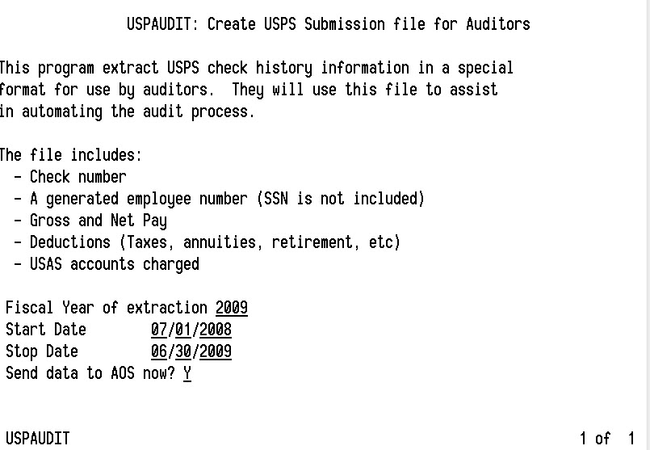
6/30/2016
7/1/2015
2016

- Date / Time

Create job calendars for FY16-17 if not already complete.

- Date / Time

Refer to the handout STRS Rate Change before processing July payrolls.

Happy FY2017 processing

