________ Include OSDI code Number – USPSDAT/DEDNAM screen
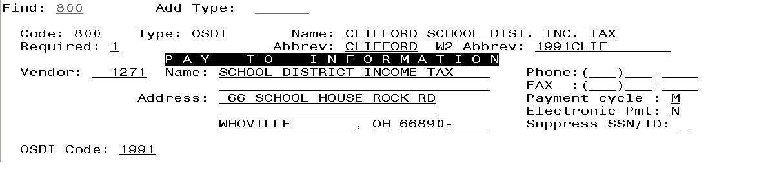

PLEASE BE SURE YOU USE THE OSDI CODE FOLLOWED
BY THE ENTITY NAME ON YOUR W2 ABBREV FIELD AS SHOWN
ABOVE.

________ Verify the Entity code in USPSDAT/DEDNAM for any city reporting
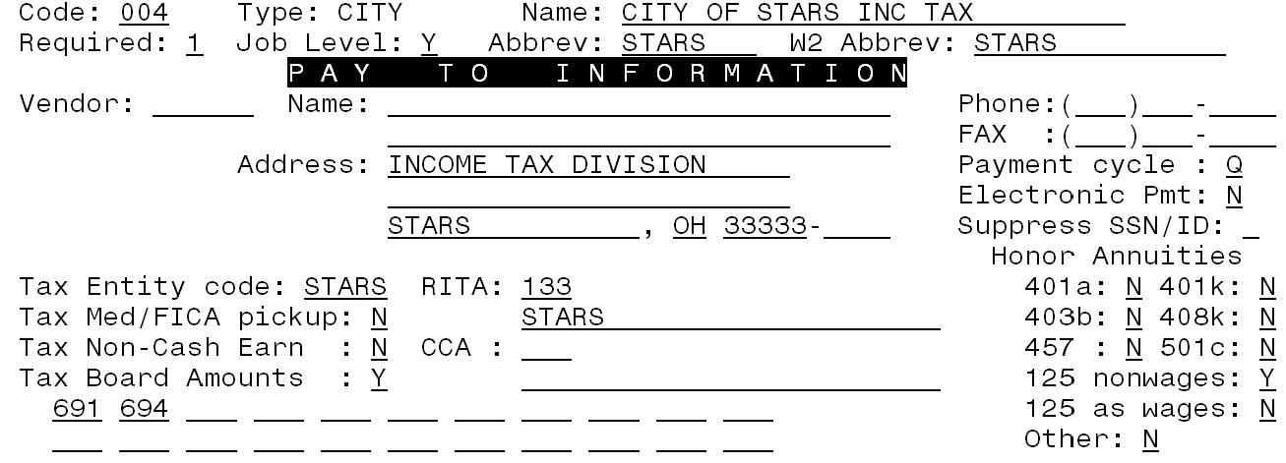

The Tax Entity Code is recommended.

The RITA/CCA code is required for the submission file.
Please see additional documents titled, “2016 Rita Withholding Tax Rates” and “2016 CCA Tax Rates.”

http://www.ccatax.ci.cleveland.oh.us click on “tax rates’
http://www.rita.to click on “tax rate table”

It is highly recommended to visit the applicable website to verify your tax
rates.

________ Verify the Employ/Residence value on all city deductions on DEDSCN
Is this city tax record required because of the employee’s place of
C = Employment or R = Residence

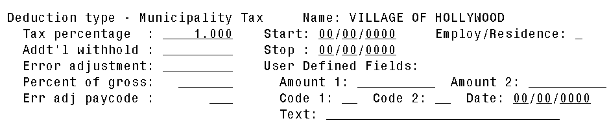

________ Health Savings Account (HSA) deduction - Annuity type in DEDNAM must be set to “I” even if there are no employee amounts withheld.

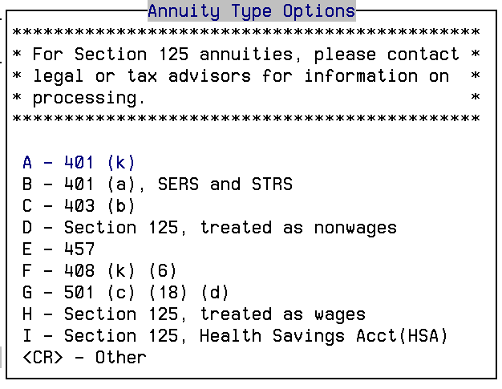

If you do not run the board contribution for the H.S.A. through payroll,
you must enter the board’s contribution to the employee’s H.S.A.
deduction record in the BOARD SHARE YTD TOTAL (on the lower
right-hand corner of the deduction record)
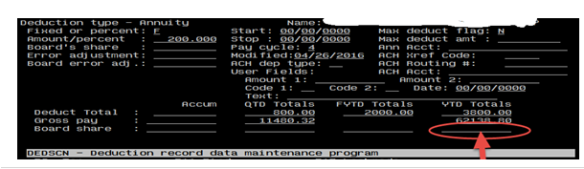

________ Employee Expense Reimbursements – If the district desires amounts paid through warrant checks to appear on the W2 form as wages, additional processing is required. For additional information please see document titled, “Reimbursements of Employee Expenses”

________ Excludable Moving Expenses – Contact Legal Advisor with questions.
Manually enter excludable amounts into the federal tax field.

________ Dependent Child Care – if NOT using the DPCARE deduction type, manually enter the dependent care amounts into the federal tax field for dependent care. The cap is $5,000. If more is withheld, balancing issues will result.

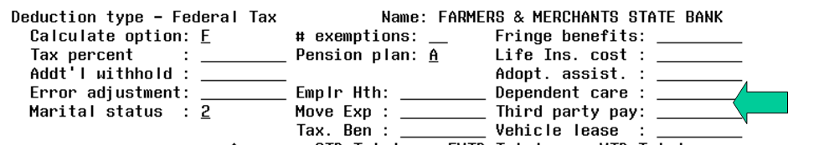

________ Fringe Benefit Amounts – IRS Publication 15- B
Enter the taxable amount in the fringe benefit field on the Federal Tax Record. Consult legal advisor with questions.

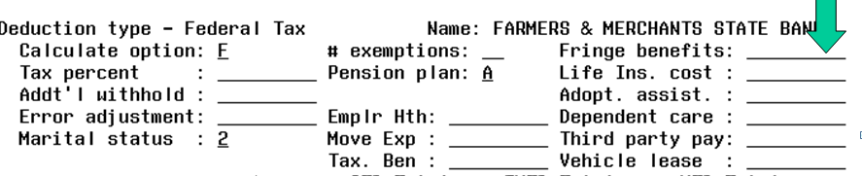

________ Pension Plan in DEDSCN 001 – this is used to determine if the retire plan box on the W2 form should be marked.
A = Automatically check the retire plan box per the calculations of W2PROC (must have an active Retirement Deduction).

Y= Yes, always check the retire plan box.

N = No, do not check the retire plan box

Employees eligible for STRS or SERS who have waived the option (typically students or board members), must have the Pension Plan field on the 001 record set to “Y.”

________ Employee Name must match the Social Security card. The W2 form will only show middle initial. The report FULL_EMP can be run to view employee names. Legal name is on BIOSCN, page 2. Use this if different from name on check from BIOSCN, page 1.

________ If district has any NC1 payments for Life Insurance purchased for withheld annuities they need entered prior to last payroll. Please see additional document titled, “Reporting Taxable Amount of Life Insurance Premiums.”

________ If district has any Third Party Sick Pay, please see additional documents titled, “Third Party Sick Pay”, and “Example of notification of Third Party Sick Payment”.

________ Employer Sponsored Health Care – Please see additional document titled, “Employer Sponsored Health Care Cost on W2.”

________ Pre run of W2PROC – run W2PROC before the last pay of 2016 has been completed. Balance the to-date figures and review and correct any warnings and errors. Do not create Tape file at this point. W2PROC can be run multiple times as long as you don’t create the tape. Please see “Balancing your W2Rept.txt” section for additional balancing information.

________ Complete processing of last payroll for current year.
- Pay all accumulated deductions. (Run PAYDED for payment option: A, projection, no other selection criteria. This will show if any outstanding deductions exist.)
- If any NC1 payments, make sure they are handled with this payroll.

________ Complete regular month-end closing.

Run the RETIRE/SERSREG program. Choose first to NOT create the tape file. This program generates a report of earnings, deposits, and days paid for the retirement system. If necessary, adjustments can be made using USPSCN/ATDSCN.

Verify that the total contribution amounts listed on the report equal the total deduction checks for the withholding plus any warrant checks written for board paid employee amounts.
Verify to be sure the contributions for each employee equal earnings times the applicable retirement percentage. Allow for rounding (within a few cents)

Review service credit days for all employees on the report. Verify that paperwork has been completed for employees listed on the report as “new”.

Once satisfied that the data is correct, run SERSREG again and choose to create the tape file. This will clear totals and create the tape submission file called SERS.yymm.

Complete and submit SERS monthly reports and payments as required.

Balance the payroll account. This step may be completed after you receive your bank statement.

Run the CHKSTA program to reconcile checks.

Run the CHKSTS program to generate an outstanding check register. Verify that your payroll clearance account balances with the bank.

Quarter-end closing

________ Balance QRTRPT

Run the demand option of QRTRPT (N). The report shows quarter, fiscal, and annual totals. Check all totals for accuracy.

In the ‘Totals’ section of QRTRPT, the gross and adjusted gross should balance using a manual calculation:

Total Gross
- Total Annuities
+ Non-Cash Earnings
-----------------
Calculated Adjusted Gross

On QRTRPT, the Calculated Adjusted Gross should equal the Total Adjusted Gross. This should be true for all adjusted gross figures in the ‘Totals’ section.

All deduction checks for the quarter should equal the total deductions showing on QRTRPT. This should be true for every deduction code. Be sure to verify the electronic transfers of federal and Medicare payments as well.

The total gross showing on QRTRPT should equal the total of all payroll clearance checks created during CHKUPD for the quarter.

For city withholding, take the taxable gross times the percentage to be sure the tax withheld and submitted are correct. Please note that mobile employees could cause discrepancies.

DO NOT RUN QRTRPT FOR OPTION Y

________ Balance Deductions

Run PAYDED to verify there are no outstanding deduction amounts.

The total of all board paid amounts (if tracked on the system) should equal the total of all warrant checks to the vendor or deduction company.

Complete and file any required quarter-end submission forms.

________ ODJFS

Run the program ODJFSRPT and generate a report only.

Check all totals carefully for accuracy.

There are 14 weeks in this quarter. (This is the number of Saturdays in quarter.)

If necessary, weeks worked may be updated utilizing the USPSCN/ATDSCN program.

________ **** When all data is correct, run the ODJFSRPT program again, this time indicating that you want to create a submission file.

________ Verify ODJFS has been closed for the quarter. Look in USPSDAT – USPCON; the ODJFS date should read 12/2016.

________ Send e-mail to USAS_LIAISONS, indicating that you have created the ODJFS submission file.

________ Printed Reports

If printed reports are desired, be sure to print copies at this time.

USPRPT/EMPMST (all data)
USPRPT/ERNSUM (All data for quarter) – condensed version of ERNREG (170 column report)
USPRPT/ERNREG (all data for the quarter)
QRTRPT (all data - demand report)

________ If you haven’t already done so, run W2proc and do NOT create the tape file at this point.

________ Balance your W2REPT.TXT report.

See the following additional handouts for information on balancing your W2REPT:
- Balancing your W2REPT.TXT
- W2REPT Reconciliation Worksheet
- Final Report for W-2 Forms (example)
- W2PROC Processing – Contains Error Information
- 2016 Wage and Tax Statement – W2 Boxes explained
- Effects of Specific Situations on W2 reporting
- 2016 General Instructions for forms W-2 and W-3

Items that can affect balancing between W2PROC and QRTRPT:
    - Dependent care benefits over limit
    - Fringe Benefits
    - Medicare pickup amounts
    - Taxable third party sick pay
    - Use of company vehicle
    - Employee expense reimbursements paid through warrant

________ Additional possible causes for balancing problems:

- Voided checks from prior calendar year
  - CHKSTS report
- Refund of annuity withheld in prior calendar year
  - AUDRPT
- Manual Updates
  - AUDRPT
- Search for YTD changes using VIEW from MENU

________ Run YTDRPT if desired.

________ Run the program W2PROC for actual (to create the tape file).

We will be sending tape files to:

Social Security Administration office
Ohio State Department of Taxation
Findlay City Tax Department (for those districts requesting it)
CCA (for those districts requesting it)
RITA (for those districts requesting it)

You will need to choose a sort option.

If you had 3rd party sick pay, enter it.

Answer Y to Create a Tape File

You will need to enter your district name, address, Federal, and State identification numbers.

There is a prompt for type of employer in W2PROC:
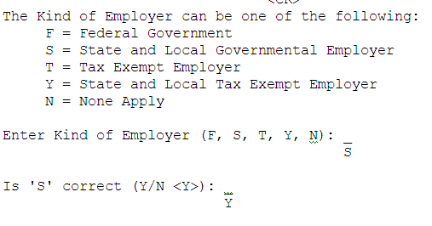
(Most schools will use “S” unless you have formally applied for tax-exempt status,
and then you will use “Y”)

Five prompts have been added to W2PROC when ‘Y’ is selected to Create Tape File. These fields are required.

- Contact name
- Contact phone number
- Contact phone extension
- Contact fax number
- Contact e-mail address

Additional deduction information can be provided to your employees using the box labeled “Other” on the W2 forms. Entering deduction code(s) will cause the year-to-date amount to print on the forms. Up to 3 deduction codes will be printed for your employees. Examples would be union dues, uniform allowance and retirement.

It is not necessary to print alignment forms.

Multiple W2’s – If an employee has more than 2 state, city or OSDI tax records, the additional W2’s will print immediately following the primary W2 and the control numbers will be in sequential order.

This program can create the following files:

- W2ERR.TXT - W2 error report, created if you receive any errors or warnings
- W2REPT.TXT - Review this report
- W2BREAK.TXT - A report showing you where the W2 forms should be separated when the sort field changes.

Do not print:
- W2TAPE.SEQ - The file to be copied to tape and submitted to the Social Security Administration.
- W2FORM.DAT – The data file NOACSC uses to print W2s
- W2FORM.TXT - The file to print on preprinted W2 forms
- W2CCA.SEQ – only CCA entities file used to send data to CCA
- W2RITA.SEQ – only RITA entities file used to send data to RITA
- W2CITY.DAT – Data file used to create city tape file to be sent electronically

*** You have the option to Delay printing your W2 forms. If you wish to delay printing, please contact usas_liaisons@noacsc.org for further instructions.

________ When your information is correct, give the command: W2_PRINT

Wait for a mail message

This program will submit your W2’s for printing. After giving this command wait for a mail message and follow the instructions.

All W2’s will be printed at the NOACSC. We will contact your office before the printed forms are shipped.

________ Send a mail message to usas_liaisons@noacsc.org when your W2 report is ready to be sent on tape. Do not submit form W3 for federal withholding.

________ The form IT-3 for state reporting MUST be sent to NOACSC. You may scan and email the document to usas_liaisons@noacsc.org

________ IF YOU WISH, you can run your BWC reports at this time in order to have
the reports now instead of later OR you can wait and run the BWC reports
during USAS year-end closing. If you choose to run it now:

Run BWC

BWC will run the BWCRPT program twice, once for sort option FUND, SCC, FUNC, and OBJ, and again for sort option FUNC, OBJ. This procedure will send an email message to you and USAS_LIAISONS when complete. We will copy these reports to the web. You may find these helpful when filling out your Worker’s Compensation report.

The output text files are:
BWCRPT_FO.txt
BWCRPT_FSFO.txt

________ Make sure all December late distributions have been posted. Do not post anything for January. Have you posted all BRDDIS batch files, all December payrolls, etc. Check with your treasurer.

________ Run the procedure CALENDARCD

When running this option, select to process NOW. This is the default. (Do not run for later.)

You will not receive an email message after running CALENDARCD.

________ Check to make sure the procedure has finished before going on to the next step. To verify, go to web reports at https://reports.noacsc.org – Payroll Reports – District - Calendar Year 2016 reports – 2016 Calendar Year End Reports. Ten reports should be listed, including YTDRPT. (QRTRPT and ODJFS do not show here. They will show up after the next step under “Fourth Quarter 2016 Reports”, Quarter Reports.)

________ Run the program: CALENDUSPS

When running CALENDUSPS, all users must be logged off the system.

Then wait for a mail message

This program will make a copy of your payroll files and zero out QTD & YTD totals. After giving this command wait for a mail message and follow the instructions.

After you receive the mail message, run QRTRPT for Option N to verify all YTD and QTD totals are 0.00.

________ Preparing for 2017

- Enter changes in tax withholding rates effective January 1, 2017

http://incometax.columbus.gov/search_taxmunicipalities.aspx/index.asp

Click on address search to check any taxing district.

- Check OSDI rates

http://www.tax.ohio.gov/school_district_income.aspx

    - Under the heading School districts with an income tax is a full list or a searchable list for the income tax.

  - Unsure if employee should have OSDI tax withdrawn?

https://thefinder.tax.ohio.gov/StreamlineSalesTaxWeb/default_schooldistrict.aspx

- Click on School District
- Lookup Tax Rate
    - Address
    - Zip Code 5 digit or 9 digit
    - Latitude/Longitude

  - Unsure if employee should have municipality tax withdrawn?

- https://thefinder.tax.ohio.gov/StreamlineSalesTaxWeb/default_schooldistrict.aspx

- Click on Municipal Tax
- Lookup Tax Rate
    - Address
    - Zip Code 5 digit or 9 digit
    - Latitude/Longitude

  - Use CHGDED for updates to deduction screens

________ CONGRATULATIONS! Begin Payroll Processing for 2017!

